CSC · CMMI ML 5.0 (DEVELOPMENT) AND ML 3.0 (SERVICES)
Data Flow Diagrams
How a data collection sheet travels from a project team's laptop to a row an analyst can query, who signs it off on the way, and what is written at each step.
Context diagram, level 1 decomposition, process specifications and the approval state machine.

1. Context diagram
Who hands the system something, and what they get back. One process at this level; everything inside it is section 2.
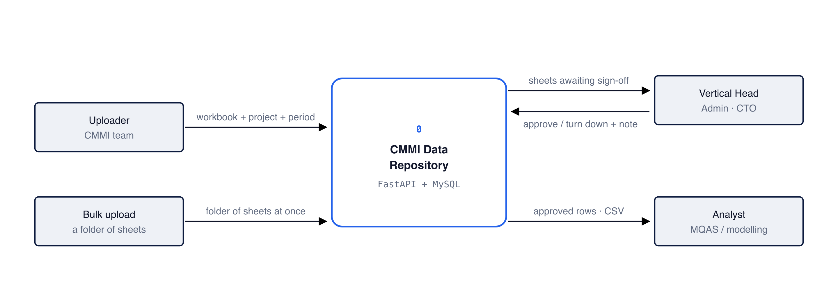
Figure 1. Approved rows are the only thing that leaves. Browse and CSV export filter on stage = 'approved', so a sheet sitting at any of the three approval stages is invisible to the analyst even though its rows are already stored.

External entities
ENTITY | ROLE
Uploader | The CMMI team member who submits a workbook, choosing the track, the project and the period. Cannot approve or delete.
Bulk upload | A whole folder of sheets loaded at once by scripts/bulk_import.py, rather than one file at a time through the web page. Those imports land as pending review like any other.
Vertical Head · Admin · CTO | The three approvers. Each sees the sheets waiting at their own stage and returns an approval or a rejection with a reason.
Analyst / MQAS | Takes approved rows out, as CSV from the browse page or by querying MySQL directly.

2. Level 1 — what happens to a workbook
Five processes, each writing to its own store. Nothing is thrown away along the way: the original file is kept as sent, every worksheet gets a row recording whether it parsed, and a heading the catalogue does not recognise is kept as JSON.
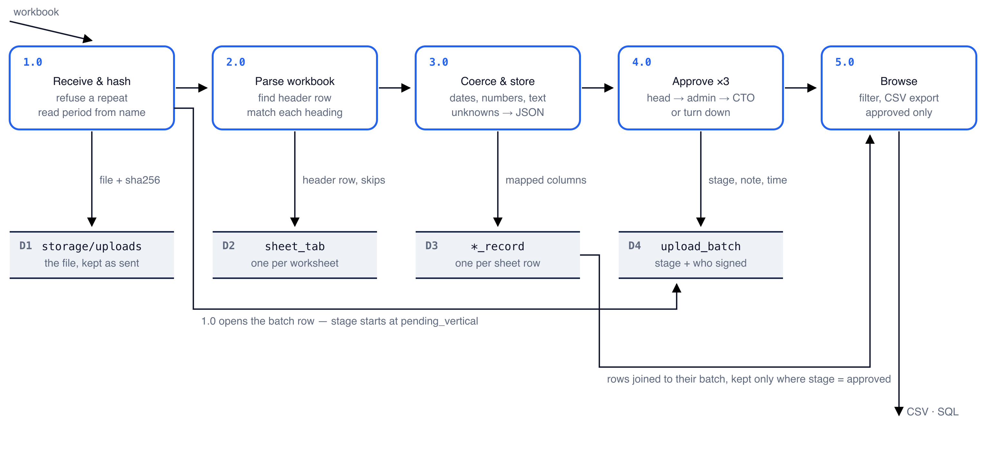
Figure 2. Rows are written at step 3, before anyone approves anything — approval only flips a column on upload_batch. That is why step 5 has to join back to the batch: the rows themselves carry no approved flag, so the join is what keeps unapproved data out of an export.

Data stores
ID | STORE | HOLDS
D1 | storage/uploads | The original file, kept byte for byte under <project>/<period>/, so it is always recoverable.
D2 | sheet_tab | One row per worksheet: its header row, the columns that mapped, or the reason it was skipped.
D3 | development_record / services_record | One row per spreadsheet row, with the sheet's columns as real columns.
D4 | upload_batch | The upload itself: who, when, file hash, stage, and each sign-off with its timestamp and note.
— | category / project / reporting_period | Reference data, seeded once. Process 1.0 reads it to resolve the project and the period.

3. Process specifications

1.0 Receive and hash
• In: the workbook, the chosen track, project and period.
• Does: writes the file to storage/uploads/<project>/<period>/ with a timestamped name; takes its SHA-256; refuses the upload if the identical bytes are already loaded for that project and period, unless 'load anyway' is ticked. Reads the period out of the file name — 'Cycle 3 (April-June)', 'Apr-May26', 'July -Sep 2025' are all understood — and offers it as an editable default, so a misread name never silently mislabels data.
• Out: D1 the file, D4 a new upload_batch row with stage = pending_vertical.

2.0 Parse workbook
• In: the stored file.
• Does: opens each worksheet and looks for the header row, which sits on row 1, 3 or 5 depending on the project. A sheet is only treated as a data collection sheet if it carries enough recognised columns and an anchor column. Each heading is then matched to one fixed column; the two Services SLA pairs are told apart by position.
• Out: D2 one sheet_tab row per worksheet — including the skipped ones, with the reason recorded.

3.0 Coerce and store rows
• In: the parsed rows and the column mapping.
• Does: converts each cell to the column's type. Dates are the hard part: a date typed into a cell Excel is treating as text stays text, and the teams write them several ways, so the parser carries thirty date formats, day first throughout. An unreadable date is stored NULL, which looks exactly like an empty cell — scripts/scan_dates.py exists to make that difference visible. Headings the catalogue does not know go to extra_columns as JSON.
• Out: D3 one record row per spreadsheet row, carrying its provenance.

4.0 Approve
• In: an approver's decision and an optional note.
• Does: checks the person's role matches the stage the sheet is waiting at, and that a vertical head covers that project. Records the sign-off against that stage and advances the sheet. A rejection records who, at which stage, and why. A sheet reaching approved marks any earlier sheet for the same project and period superseded.
• Out: D4 the stage, the approver, the timestamp and the note.

5.0 Browse and export
• In: the viewer's filters — track, project, period.
• Does: reads D3 joined to D4 and keeps only rows whose batch is approved. Shows only columns that actually hold data for the current selection, because a 43-column table is unreadable when half of it is empty.
• Out: the table on screen, and the same rows as a flat CSV.

4. The approval chain
One stage column on upload_batch moves through four values. Each stage belongs to exactly one role, so no one can sign twice — an administrator cannot also give the vertical head's approval and thereby sign off a sheet alone.
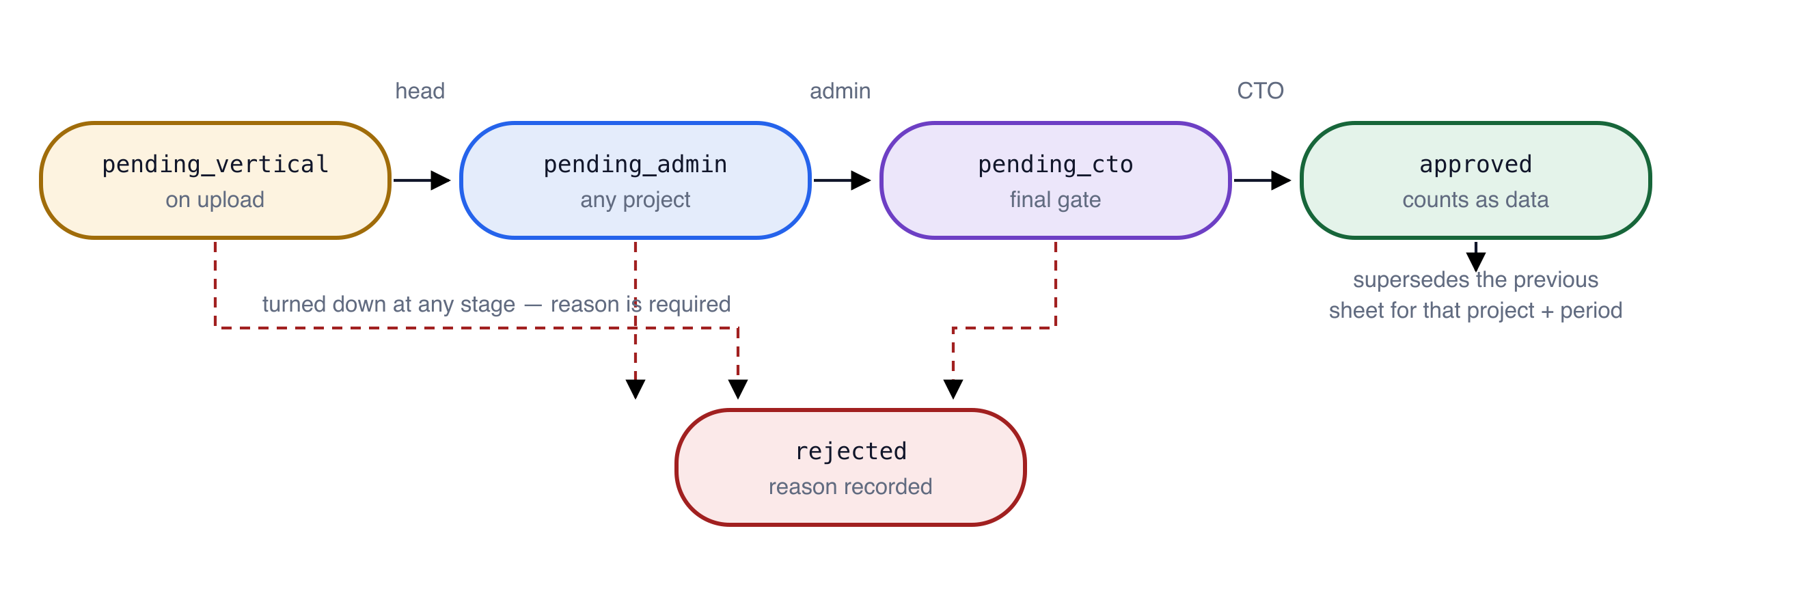
Figure 3. There is no path back from rejected. A turned-down sheet is corrected outside the system and uploaded again as a new batch, which is why the rejection reason is kept on the old row rather than cleared.

What each role may do
ROLE | MAY
Uploader | Upload sheets. Cannot approve or delete. Sees their own uploads.
Vertical Head | First approval, for the projects assigned to them only. A head with no assignment covers none — access is granted deliberately rather than by omission.
Administrator | First approval for any project, manages sign-ins, and the only role that can delete.
CTO | Final approval across all projects. Senior, but cannot delete.

Stage values
STAGE | WAITING ON | MEANS
pending_vertical | Vertical Head | Set on upload. The sheet is parsed and its rows are stored, but not yet counted.
pending_admin | Administrator | The vertical head has signed.
pending_cto | CTO | The administrator has signed.
approved | — | Counts as data. Appears in browse and export. Supersedes the previous sheet for that project and period.
rejected | — | Turned down, with who, at which stage, and why. Terminal.

5. Rules the diagrams encode
• A repeat upload is refused. The file is hashed on arrival; identical bytes already loaded for the same project and period are rejected unless the uploader ticks 'load anyway'. Any earlier load of the same bytes counts, including one that failed to parse — otherwise an unreadable file is silently re-added at every import.
• A newer approved sheet supersedes the old one. It is marked superseded rather than deleted, so the earlier figures stay auditable.
• Nothing counts until the CTO signs. Rows exist in the database from step 3, but every read path filters on the approval stage.
• The trail is the record itself. Each sign-off writes its approver and timestamp onto the upload row, and the Activity page reads them back out — one upload produces up to five dated events.
Drawn from app/models.py, app/ingest.py, app/metrics_catalog.py and app/main.py, with row counts and foreign keys read from the live MySQL schema on 9 October 2026. Source diagrams: docs/*.svg.

